**Lab Assignement-3**

**Name: Hemang Kanjariya**

**Class: FY-B**

**Roll No:3**

**Q1- Write a program to insert stack and display.**

/*Name:Hemang Kanjariya

Class:FY-B

Roll No:3*/

#include<stdio.h>

#include<conio.h>

#define SIZE 4

int inp_array[SIZE],top = -1;

void push(){

int x;

if(top == SIZE - 1){

printf("\n overflow");

}

else{

printf("\nEnter the element to be added onto the stack:");

scanf("%d",&x);

top = top + 1;

inp_array[top] = x;

}

}

void show(){

int i;

if (top == -1)

{

printf("\nUnderflow");

}

else{

printf("\nElements present in the stack:\n");

for(i = 0; i<top+1; i++){

printf("%d\n",inp_array[i]);

}

}

}

void main(){

int i,op;

clrscr();

printf(" Name:Hemang Kanjariya\n Class:FY-B\n Roll No:3\n");

for(i=0;i<SIZE;i++){

printf("\nEnter the all elements[%d]:",i);

scanf("%d",&inp_array[i]);

top = top + 1;

}

while(1){

printf("\nFor push Elemnt enter 1");

printf("\nFor pop enter 2");

printf("\nFor Showing stack elemnts enter 3");

printf("\nFor Exit enter 4");

printf("\n Select the operation to be performed:");

scanf("%d",&op);

switch(op){

case 1:

push();

break;

/* case 2:

pop();

break;*/

case 3:

show();

break;

case 4:

exit(0);

break;

default:

printf("Enter Valid value");

}

}

getch();

}

**Output:-**

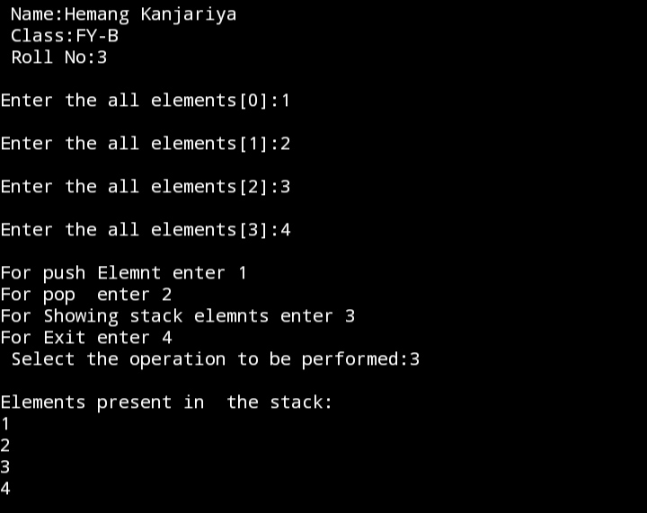

**Q2-Write a Program to Delete a stack and display.**

#include<stdio.h>

#include<conio.h>

#define SIZE 4

int inp_array[SIZE],top = -1;

void pop(){

if(top == -1)

{

printf("\nUNderflow");

}

else{

printf("\nPopped element: %d",inp_array[top]);

top = top - 1;

}

}

void push(){

int x;

if(top == SIZE - 1){

printf("\n overflow");

}

else{

printf("\nEnter the element to be added onto the stack:");

scanf("%d",&x);

top = top + 1;

inp_array[top] = x;

}

}

void show(){

int i;

if (top == -1)

{

printf("\nUnderflow");

}

else{

printf("\nElements present in the stack:\n");

for(i = 0; i<top+1; i++){

printf("%d\n",inp_array[i]);

}

}

}

void main(){

int i,op;

clrscr();

for(i=0;i<SIZE;i++){

printf("\nEnter the all elements[%d]:",i);

scanf("%d",&inp_array[i]);

top = top + 1;

}

while(1){

printf("\nFor push Elemnt enter 1");

printf("\nFor pop enter 2");

printf("\nFor Showing stack elemnts enter 3");

printf("\nFor Exit enter 4");

printf("\nSelect the operation to be performed:");

scanf("%d",&op);

switch(op){

case 1:

push();

break;

case 2:

pop();

break;

case 3:

show();

break;

case 4:

exit(0);

break;

default:

printf("Enter Valid value");

}

}

getch();

}

**Output:-**

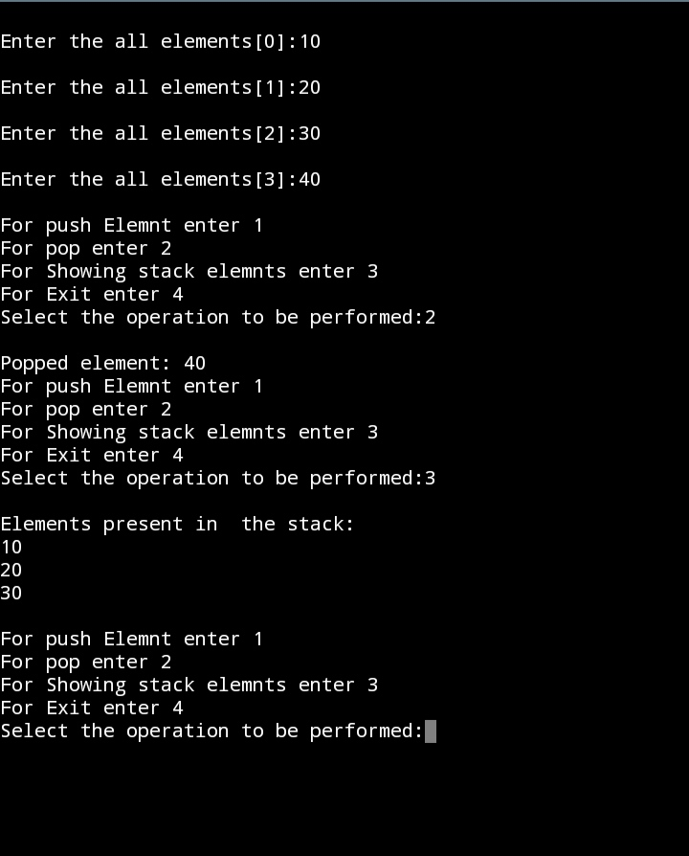 **Q3- Write a program to insert Queue element and display queue.**

/*Name:Hemang Kanjariya

Class:FY-B

Roll No:3*/

#include<conio.h>

#include<stdio.h>

#define SIZE 100

int arr[SIZE];

int rear=-1;

int front = -1;

void enqueue(){

int insert_item;

if(rear == SIZE - 1)

printf("Overflow!\n");

else{

if(front == -1)

front = 0;

printf("Element to be inserted in the queue:");

scanf("%d",&insert_item);

rear = rear+1;

arr[rear] = insert_item;

}

}

/*void dequeue(){

if(front == -1 || front>rear){

printf("Underflow!\n");

}

else{

printf("Element deleted from the queue: %d\n",arr[front]);

front = front+1;

}

}*/

void show(){

int i;

if(front == -1)

printf("Empty Queue\n");

else{

printf("Queue:\n");

for(i=front; i<=rear; i++){

printf("%d",arr[i]);

printf("\n");

}

}

}

void main(){

int ch;

printf(" Name:Hemang Kanjariya\n Class:FY-B\n Roll No:3\n");

while(1)

{

printf("\n1.Enqueue operation");

printf("\n2.Dequeue operation");

printf("\n3.Display Queue");

printf("\n4.Exit");

printf("\nEnter your choice of operation:");

scanf("%d",&ch);

switch(ch){

case 1:

enqueue();

break;

/*case 2:

dequeue();

break;*/

case 3:

show();

break;

case 4:

exit(0);

break;

default:

printf("Enter valid number.");

}

}

getch();

}

**Output:-**

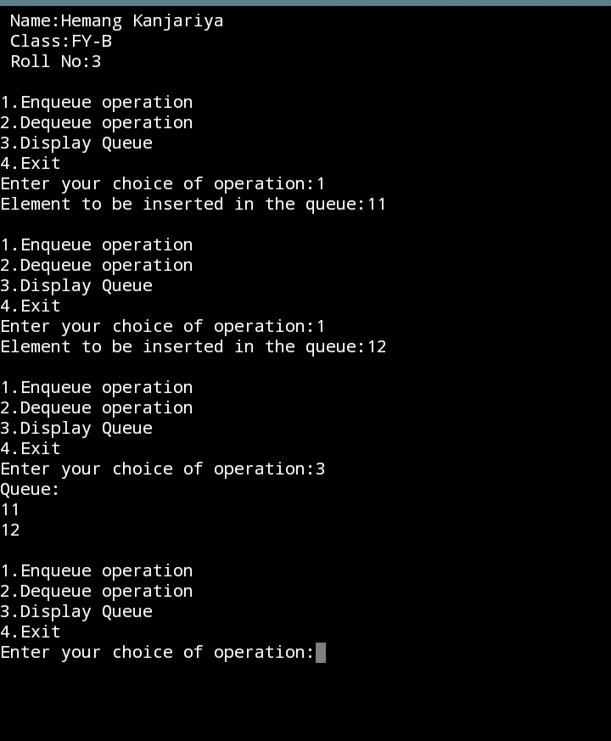

**Q4- Write a program Dequeue the element and Display .**

#include<conio.h>

#include<stdio.h>

#define SIZE 100

int arr[SIZE];

int rear=-1;

int front = -1;

void enqueue(){

int insert_item;

if(rear == SIZE - 1)

printf("Overflow!\n");

else{

if(front == -1)

front = 0;

printf("Element to be inserted in the queue:");

scanf("%d",&insert_item);

rear = rear+1;

arr[rear] = insert_item;

}

}

void dequeue(){

if(front == -1 || front>rear){

printf("Underflow!\n");

}

else{

printf("Element deleted from the queue: %d\n",arr[front]);

front = front+1;

}

}

void show(){

int i;

if(front == -1)

printf("Empty Queue\n");

else{

printf("Queue:\n");

for(i=front; i<=rear; i++){

printf("%d",arr[i]);

printf("\n");

}

}

}

void main(){

int ch;

while(1)

{

printf("\n1.Enqueue operation");

printf("\n2.Dequeue operation");

printf("\n3.Display Queue");

printf("\n4.Exit");

printf("\nEnter your choice of operation:");

scanf("%d",&ch);

switch(ch){

case 1:

enqueue();

break;

case 2:

dequeue();

break;

case 3:

show();

break;

case 4:

exit(0);

break;

default:

printf("Enter valid number.");

}

}

getch();

}

**Output:-**

